Pro Series
Industrial Router
UR32

UR32 is a cost-effective industrial cellular router with embedded intelligent features that are designed for multifarious M2M/IoT applications. Global WCDMA and 4G LTE carrier supported make this drop-in connectivity a great help for operators in maximizing uptime.

Integrating embedded cellular modem and dual SIM function, the UR32 provides 3G/4G cellular network with 150 Mbps download and 50 Mbps uplink, it also has 2 fast Ethernet ports and supports Wi-Fi that compliance with 802.11b/g/n standard. All these capabilities deliver users an uninterrupted internet access.

Easy deployment and comprehensive remote device management makes UR32 versatile in most of IoT/M2M applications.

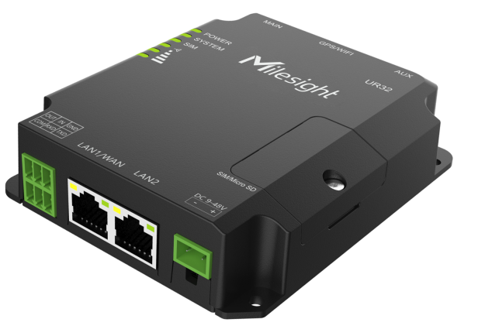

- Application Example
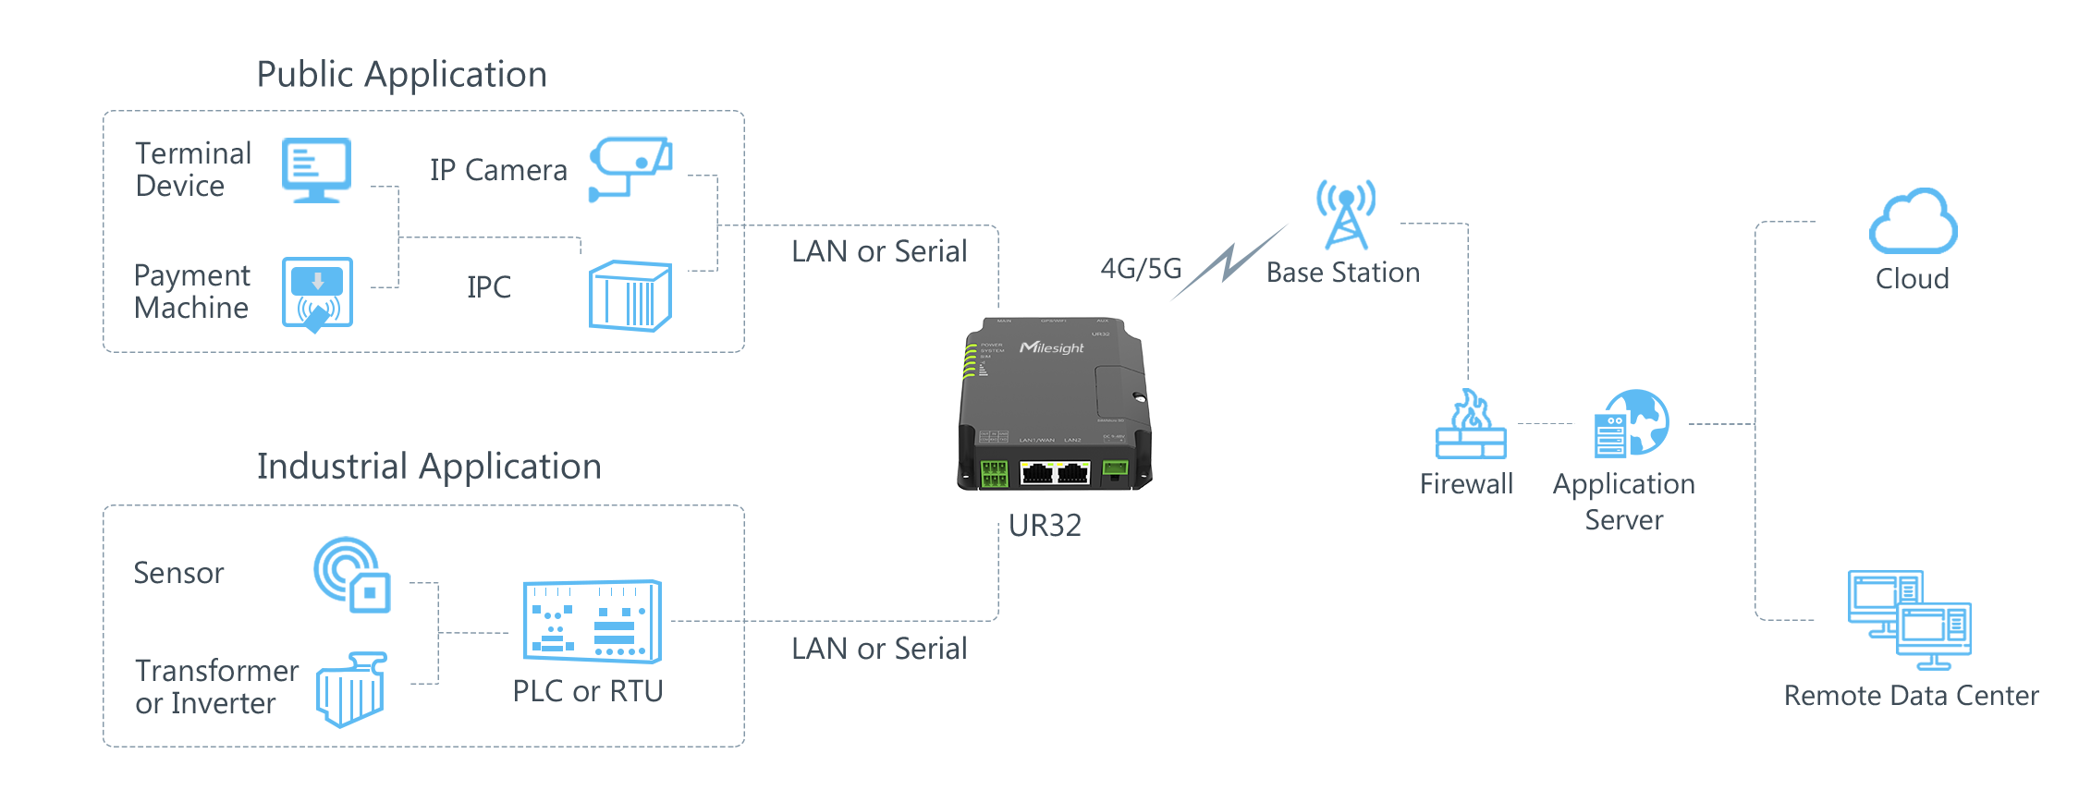
- Benefits  - NXP industrial grade processor  - Global 4G LTE CAT4/3G network with dual SIM cards for backup between multiple carrier networks  - Embedded Python SDK for secondary development  - Flexible modular design provides users with different connection modules like Ethernet, I/O, serial port, Wi-Fi, GPS for connecting diverse field assets  - Rugged enclosure, optimized for DIN rail or shelf mounting  - 3-year warranty included  - Security & Reliability  - Automated failover/failback between Ethernet, Cellular (dual SIM) and Wi-Fi  - Secure transmission with VPN tunnels like IPsec/OpenVPN/GRE/L2TP/PPTP/DMVPN  - Embeds hardware watchdog to automatically recover from various failures, ensure highest level of availability  - Establishes a secured mechanism on centralized authentication and authorization of device access by supporting AAA (Radius, TACACS+, LDAP, local Authentication) and multiple levels of user authority |  | - Capabilities  - Link remote devices in an environment where communication technologies are constantly changing  - Support 802.11 b/g/n, as AP or client mode, to establish versatile wireless network or be the backup WAN link for 4G/3G  - Support rich protocols like SNMP, Modbus bridging, RIP, OSPF  - Support wide operating temperature ranging from -40°C to +70°C/-40℉ to +158℉  - Easy Maintenance  - DeviceHub provides easy setup, mass configuration, and centralized management of remote devices  - The user-friendly web interface design and more than one option of upgrade help administrator to manage the device as easy as pie  - WEB GUI and CLI enable the admin to achieve simple management and quick configuration among a large quantity of devices  - Efficiently manage the remote routers on the existing platform through the industrial standard SNMP

- Specifications
Hardware System
CPU | ARM Cortex-A7，528 MHz
Memory | 128 MB DDR3 RAM and 128MB Flash
Extendable Storage | 1 × Micro SD
Cellular Interface
Antenna Connector | 2 × 50 Ω SMA Connectors (Center PIN: SMA Female)
SIM Slots | 2（Mini SIM-2FF）
Ethernet Interface
Numbers | 2 × 10/100 Mbps
Property | 1 × WAN + 1 × LAN or 2 × LAN
Mode | Full or half duplex (Auto-Sensing)
PoE | 2 × 802.3 af/at PoE PSE on LAN Ports (Optional)
Wi-Fi Interface (Optional)
Antenna Connector | 1 × 50 Ω SMA Connector (Center PIN: RP-SMA Female)
Standards | IEEE 802.11 b/g/n，2.4GHz
Tx Power | 802.11b: 16 dBm +/-1.5 dBm (11 Mbps)  802.11g: 14 dBm +/-1.5 dBm (54 Mbps)  802.11n: 13 dBm +/-1.5 dBm (65 Mbps, HT20/40 MCS7)
Modes | AP or Client mode
Security | WPA/WPA2 authentication, WEP/TKIP/AES encryption
GPS (Optional)
Antenna Connector | 1 × 50 Ω SMA Connector (Center PIN: SMA Female)
Protocol | NMEA0183, PMTK
Serial Interface
Numbers | 1 × RS232 (RS485 Optional)
Connector | 3.5mm Terminal Block
Baud Rate | 300bps to 230400bps
DI/DO
Numbers | 1 × DI (dry contact) + 1 × DO (wet contact), Galvanic Isolation
Connector | 3.5mm Terminal Block
Maximum V/A | 0.3A@30VDC (DO)
Others
Reset Button | 1 × RESET
LED Indicators | 1 × POWER, 1 × SYSTEM, 1 × SIM, 3 × Signal strength
Built-in | Watchdog, Timer
Software
Network Protocols | IPv4/IPv6, PPP, PPPoE, SNMP v1/v2c/v3, TCP, UDP, DHCP, RIPv1/v2, OSPF, DDNS, VRRP, HTTP, HTTPS, DNS, ARP, QOS, SNTP, Telnet, VLAN, SSH, etc.
VPN | DMVPN, IPsec, OpenVPN, PPTP, L2TP, GRE
Security | Access Control, DMZ, Port Mapping, MAC Binding, SPI Firewalls,  DoS&DDoS Protection, Filtering(IP&Domain), IP Passthrough
Management | Web, CLI, SMS, On-demand dial up, SNMP v1/v2/v3, DeviceHub
AAA | Radius, Tacacs+, LDAP, Local Authentication
Multilevel Authority | Multiple Levels of User Authority
Reliability | VRRP, WAN Failover, Dual SIM Backup
Serial Port | Transparent(TCP Client/Server, UDP), Modbus Master/Slave, Modbus Gateway (Modbus RTU to Modbus TCP)
Power Supply and Consumption
Power Connector | 2-pin 5.08 mm Terminal Block
Input Voltage | 9-48 VDC, with Surge-Protection and Reverse Polarity Protection
Power Consumption | Typical 1.9 W, Max 2.4 W (In Non-PoE mode)
Physical Characteristics
Ingress Protection | IP30
Housing & Weight | Metal, 271 g
Dimension | 108 x 90 x 26 mm (4.25 x 3.54 x 1.02 in)
Installation | Desktop, Wall or DIN Rail Mounting
Environmental
Operating Temperature | -40°C to +70°C (-40℉ to +158℉)  Reduced Cellular Performance Above 60°C
Storage Temperature | -40°C to +85°C (-40℉ to +185℉)
Ethernet Isolation | 1.5 kV RMS
Relative Humidity | 0% to 95% (non-condensing) at 25°C/77℉
Approvals
Regulatory | CE, FCC, RCM, NBTC, SPDDI
Carrier | PTCRB, AT&T
Environmental | RoHS
EMC | EN 55032, EN 55035
EMS | IEC 61000-4-2 Level 3  IEC 61000-4-3 Level 2  IEC 61000-4-4 Level 2  IEC 61000-4-5 Level 2  IEC 61000-4-6 Level 3  IEC 61000-4-8 Level 1  IEC 61000-4-11 Level 3
Radio Frequency | EN 301 489-1/17/19/52, EN 301 511, EN 301 908-1/2/13, EN 303 413, EN300 328
Safety | EN62368-1

- Dimensions(mm)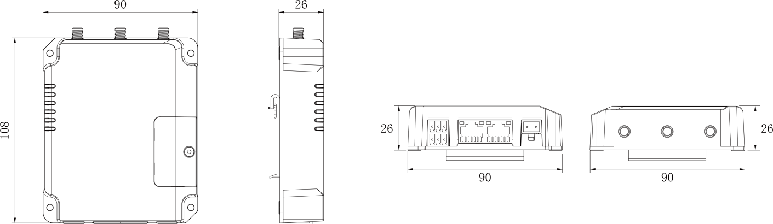

- Accessories
2 × Magnetic Cellular Antennas
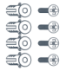
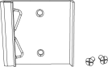
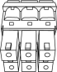
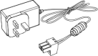
4 × Wall Mounting Kits
1 × DIN Rail Kit
1 × 6-Pin Pluggable
Terminal
1 × Power Adapter

1 × Wi-Fi Antenna
(Wi-Fi Version Only)
2 × Stubby Cellular Antennas (Optional)
1 × GPS Antenna
(GPS Version Only)

*Note: Contact us if you need any other special accessories or customized accessories.

