DS-KLB2-12
Smart cabinet – Auxiliary cabinet (12 grids)

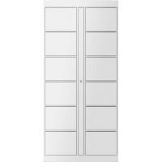

- Auxiliary cabinet with 12 girds
- Dimension: 880*477*1880mm (Width*Depth*Height)
- Grid dimension: 372*277*477mm
- Grid load: 25 kg
- Communication: communicate with the main cabinet via RS485
- Power supply: 12V 2A (powered by the main cabinet, no need for a separate power supply)
- Emergency cabinet opening: support push-pull rod on the top of the cabinet;
- Door status detection: The micro switch is integrated into the cabinet to detect the switch status of the cabinet door in real time.

- Parameters
Physical Interface
RS485 | 1
General
Power Supply | DC12V
Working environment | Indoor
Cabinet parameters
Qty of grids | 12
Material | Cold-rolled steel

- Available model
DS-KLB2-12

- Dimension
